RS232 - "RECOMMENDED STANDARD 232"

RS-232 is a standard introduced in 1960 for serial communication/transmission of data. It formally defines the signals connecting between a DTE (data terminal equipment) such as a computer terminal, and a DCE (data circuit-terminating equipment or data communication equipment), such as a modem. The RS-232 standard had been commonly used in computer serial ports. The standard defines the electrical characteristics and timing of signals, the meaning of signals, and the physical size and pinout of connectors. An RS-232 serial port was once a standard feature of a personal computer, used for connections to modems, printers, mice, data storage, uninterruptible power supplies, and other peripheral devices. In modern personal computers, USB has displaced RS-232 from most of its peripheral interface roles.
The RS-232 specification denotes usage of a 25 pin cable, where each pin has a specific usage. However, most devices never need to use all of the pins, so the cabling requirements for specific devices may vary. Many common serial devices (modems for example), use a 9 pin serial connection.

PIN CONFIGURATION and DESCRIPTION:

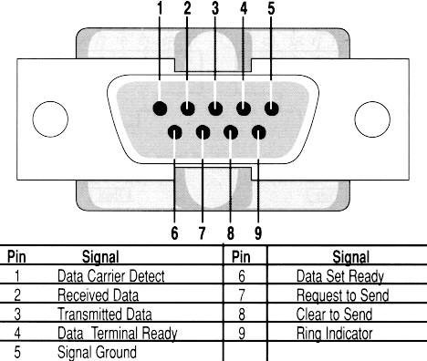

• CD/DCD(Data Carrier Detect)-Tells the computer that the modem is connected by telephone with another modem.
• RD(Receive Data)-Data transmitted from the modem to the computer.
• TD(Transmit Data)-Data transmitted from the computer or terminal to the modem.
• DTR(Data Terminal Ready)-Tells the modem that the computer is turned on and ready to accept connections.
• SG(Signal Ground)-Reference point for all signal voltages.
• DSR(Data Set Ready)-Tells the computer that the modem is turned on. The computer should not send the modem commands if this signal is not present.
• RTS(Request to Send)-Tells the modem when it can transmit data. Sometimes the computer is busy and needs to have the modem wait before the next character is transmitted
• CTS(Clear to Send)-Tells the computer when it's okay to transmit data. Sometimes the modem is busy and needs to have the computer wait before the next character is transmitted.
• RI(Ring Indicator)-Tells the computer that the telephone is ringing.

NOTE
The maximum speed, according to the standard, is 20kbit/s. However, modern equipment can operate much faster than this. (i.e. Lynx can reach 115200 baud.)The length of the cable also plays a part in maximum speed. The longer the cable and the slower the speed at which you can obtain accurate results.
RS232 works in negative logic. The RS-232 standard defines the voltage levels that correspond to logical one and logical zero levels for the data transmission and the control signal lines. Valid signals are either in the range of +3 to +15 volts for logic zero or the range −3 to −15 volts for logic one with respect to the "Common Ground" (GND) pin.

Interconnection between DTE and DCE

This is the "classic" interface for DTE/DCE connections. It is based on a 25-pin plug and socket, of which only 8 pins (often less) are normally used:
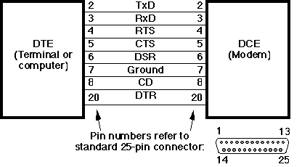
Interconnection between DTE and DTE
- Designed for DTE-DCE connections, but commonly used to connect DTE-DTE -introduces need for a null modem,
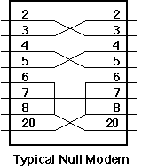
- Use straight-thru cable to connect DTE-DCE (the intended RS-232 use).
- Use null modem (or cross over cable) to connect DTE-DTE. We need a null modem as signals are unidirectional. There are different ways to wire a null modem.
- Non standard use of handshaking signals for flow control,
- Null modems can be wired differently for no handshaking, standard handshaking, a number of non-standard handshaking, and synchronous transmission.

